Tuning shock absorbers using the shock speed histogram

The shock speed histogram is a useful method to characterize race car shock absorber characteristics and performance from data recorded by the onboard data logger. This paper covers shows the reader how to use shock speed histograms to learn more about shock absorber behaviour and how to use these diagrams to tune them.

- Introduction

The purpose of a shock absorber on a race car is twofold: to minimize the variation between the tire’s contact patch and the track surface, but also to influence the transient chassis motions as the car is subjected to lateral, longitudinal and vertical acceleration.
Shock absorbers are speed sensitive. They develop a force which is proportional to the speed at which they compress or extend. When you compress a shock absorber slowly, the resisting force will be smaller than when you try to compress it faster. As a comparison, springs develop a force proportional to the distance they’re compressed or extended, regardless of the speed of this movement.
Basically, this means that a spring develops its maximum force at maximum deflection whereas a shock absorber reaches its maximum force there where the shaft speed is at a maximum.

The characteristic of any given shock absorber can be tested on a shock dynamometer. This will typically give you a shock force versus shaft speed as illustrated in Figure 1. A graph such as this will show you which force is developed at a particular speed and this for compression and extension (bump or rebound).

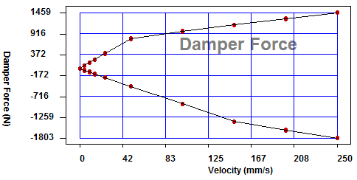
Figure 1 Shock force versus shaft speed.

- Shock speed

The first step in shock absorber tuning is to determine the characteristic that is in the shock absorber. For this we need to test it on a dynamometer to obtain the shock force versus shaft speed curve. Next we have to look at which speeds a shock absorber is subjected to as the car travels down the racetrack. This we can determine from recorded suspension data. Linear potentiometers are typically used to measure suspension movement. When the potentiometer is placed in line with the shock absorber we’re measuring shock absorber movement. If this is not the case then there’s a certain motion ratio between the signal of the potentiometer and the shock movement. This motion ratio can easily be determined by removing the spring from the suspension and jacking the wheel up and down.

A simple mathematical channel allows us to calculate the shock speed by taking the first derivative of the shock movement channel. When we illustrate both channels as a function of time we will see something resembling the graph in Figure 2.

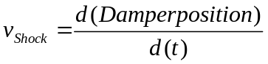

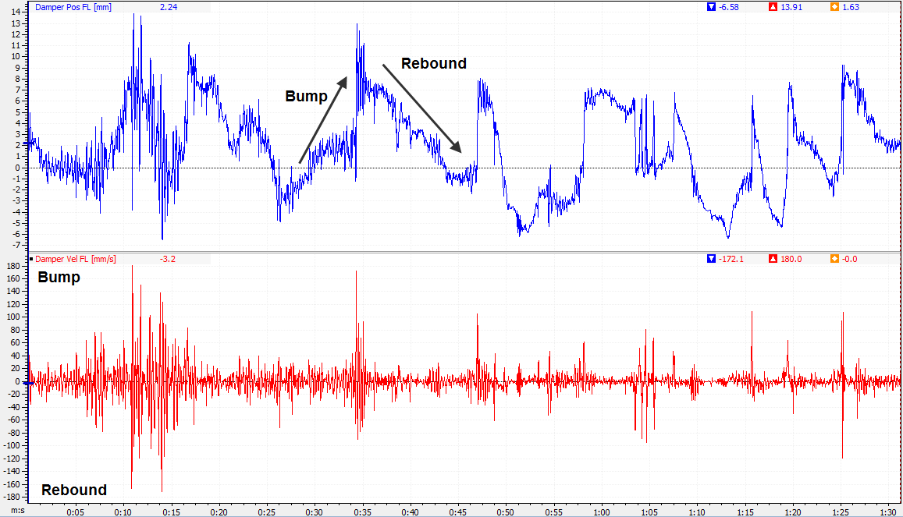

Figure 2 Shock absorber movement and speed logged data.

The upper trace in Figure 2 shows us the damper travel along a lap around the racetrack. An increasing trend in this graph corresponds to compression of the shock absorber (bump), while a decreasing trend indicates that the shock absorber is in extension (rebound). In the lower trace, the shock speed, this means that a positive value indicates bump, while a negative value means rebound.
A quick look at this trace shows us a small amount of peaks into the region of ±180 mm/s, while the bulk of the shock speed is located between ±20 mm/s.
Generally the low speed range of the shock absorber will influence the transient handling of the car when it is subjected to lateral, longitudinal and vertical acceleration, while the high speed range takes care of road input. For the sake of argument, we will distinguish the following shock speed ranges:

- Below ±5 mm/s Suspension friction (shock absorber seals, suspension
joints,…)

- 0 – ±25 mm/s Inertial chassis motion (roll, pitch and heave)

- ±25 – 200 mm/s Road input (bumps)

- Plus ±200 mm/s Curbs

When we relate this back to the example above, the main conclusion has to be that shock absorber modifications in the range of ±5 – 25 mm/s will have a significant effect, simply because the shock is spending most of its time in this range. Another way to illustrate this is to create a histogram of our shock speed channels. An example of a shock speed histogram is given in Figure 3. Much more than a time based graph, the shock speed histogram shows us how much time the shock absorber is spending in each speed interval. It tells us something about the behaviour of the shock integrated into the vehicle’s suspension system. This makes that the shock speed histogram is a very useful tool to tune the shock absorbers on the car.

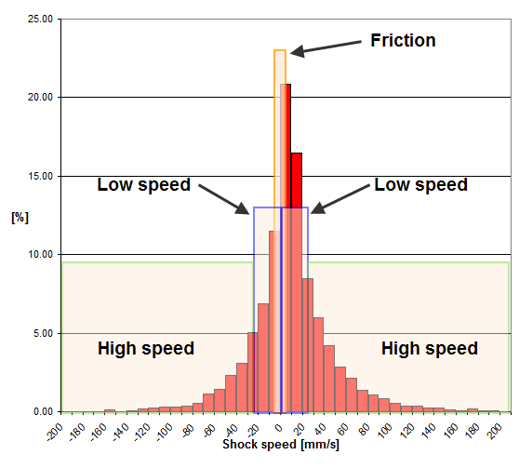
Figure 3 Shock speed histogram

- Shock speed histogram shape

To investigate what kind of effect different suspension parameters will have on the shape of the shock speed histogram we mathematically model a wheel corner as a very basic mass spring damper system as illustrated in Figure 4. To keep it simple we do not take into account any unsprung mass or tire spring rate.

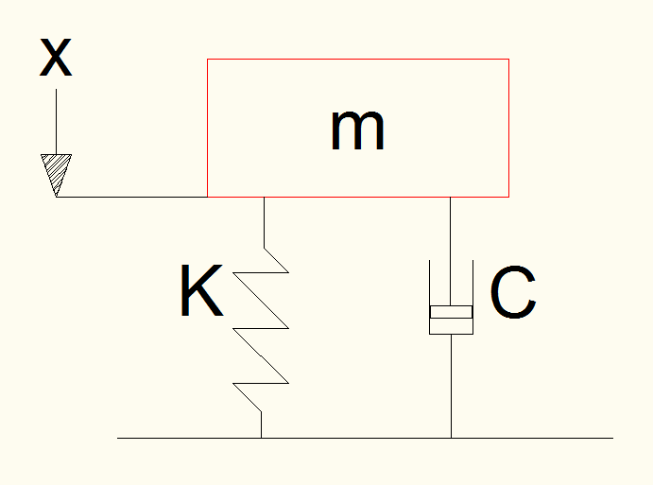
Figure 4 Mass – Spring – Damper system

In this system m represents the mass of the wheel corner (corner weight), K is the suspension spring rate and C the damping coefficient.
This system can be described by the following equation:

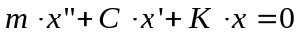 Equation 3.1

This definition states that the sum of suspended mass (m) times its acceleration (x"), the speed of the mass (x') multiplied by a damping constant (C) and the mass displacement (x) times a spring rate (K) equals zero.
Equation 3.1 can be rearranged to the following differential equation:
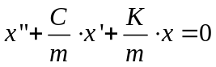 Equation 3.2

Next, we define the following parameters:

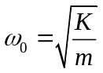 Equation 3.3
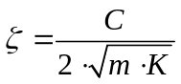 Equation 3.4

ω₀ is called the natural frequency of the system, while ζ is the damping ratio. With these 2 parameters we can rearrange equation 3.2 again:

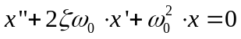 Equation 3.5

To solve this differential equation we assume that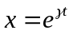, so 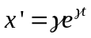and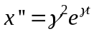. When we substitute this in equation 3.5 we get:

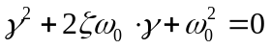 Equation 3.6

The solution of this 2nd order differential equation is:

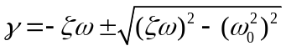 Equation 3.7

To make it a bit easier we substitute 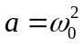and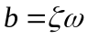:

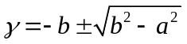 Equation 3.8

Now we need to consider 3 cases:

- 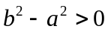
In this case the damping force is significantly larger than the spring force and the system is considered to be overdamped. We can calculate γ as 2 real numbers. The general solution of the system will be:

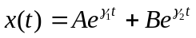 Equation 3.9

A and B are constants that depend on the initial conditions of x and x'.
- 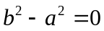
Here the damping force balances the spring force which is called critical damping. In this case 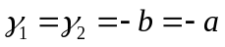resulting in the following solution for the system:

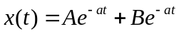 Equation 3.10

- 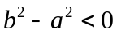
Now the damping force is less than the force of the spring (underdamped system) and the solutions from equation 3.8 will be the complex numbers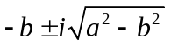. With 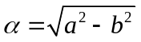the general solution for the system becomes:

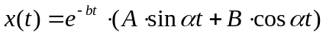 Equation 3.11

Using Matlab and equations 3.9 to 3.11 we can now simulate a basic suspension corner that is excited by a single bump and investigate the shape of the resulting shock speed histogram. Consider the following cases where the suspension hits a 10mm bump:

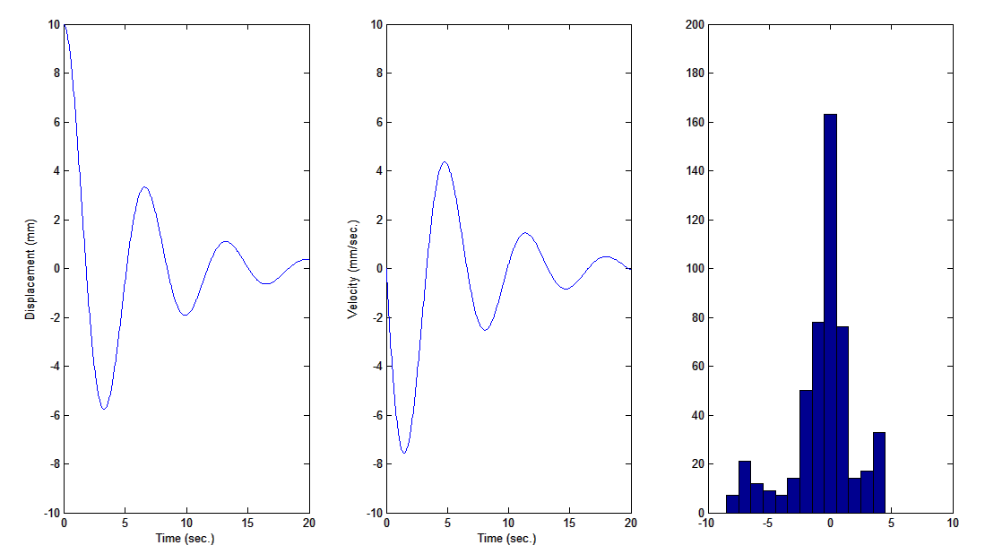
Figure 5 Mass m = 300 kg ; Spring rate K = 280 N/mm ; Damping constant C = 100Ns/mm

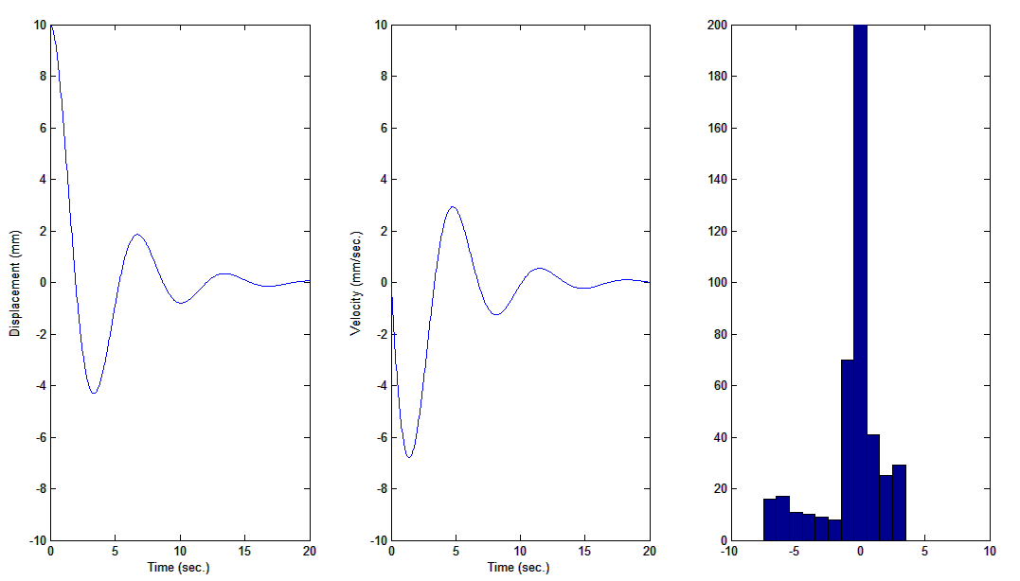
Figure 6 Mass m = 300 kg ; Spring rate K = 280 N/mm ; Damping constant C = 150Ns/mm
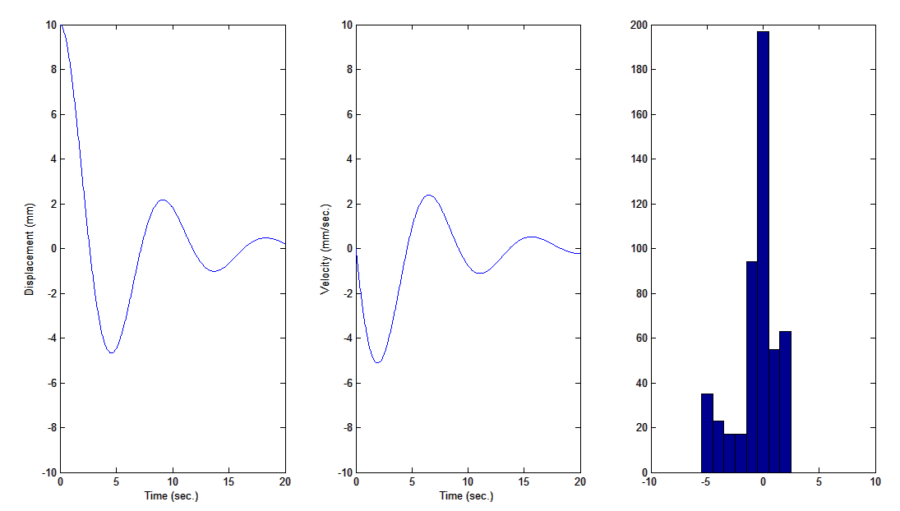
Figure 7 Mass m = 300 kg ;Spring rate K = 150 N/mm ; Damping constant C = 100Ns/mm
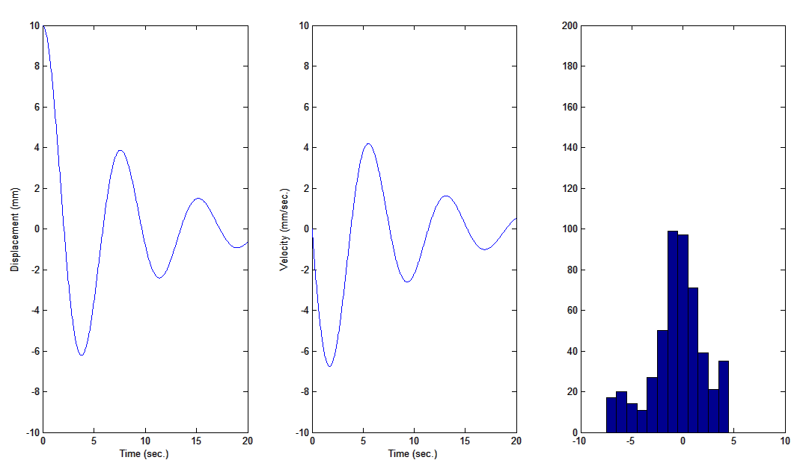
Figure 8 Mass m = 400 kg ; Spring rate K = 280 N/mm ; Damping constant C = 100Ns/mm

Of course the histograms above will never result in a perfect Gauss distribution as we're looking at only one single event, but the illustrations do give us an idea of the influence of different suspension parameters on the shape of the histogram. Some general conclusions from the graphs above are:

- Increasing the damping constant will make the histogram peak around zero higher and make the foot of the histogram less wide (the histogram becomes sharper).
- Softening the spring rate has the same effect. The suspension will in this case be more compliant and as the damping constant remains the same there's more damping force to slow down the movement of the sprung mass.
- Increasing the sprung mass lowers the peak of the histogram and make the foot wider. The increased mass makes it more difficult for the spring and damper to slow down the movement, so there is more speed variation.

Further on in this paper we'll investigate the effects of some set-up parameters on the shock speed histogram shape using real data to confirm the conclusions above.

Of course we would like to know what the ideal shape is of the 4 shock speed histograms on our race car. In order to obtain a tire contact patch load with as little variation as possible, the exercise is to implement set-up changes that make the histograms as symmetrical as possible. Ideally we would like to work towards a normal distribution (Gauss curve).
To illustrate that this is the case mathematically would go too far for this paper but let's approach the matter logically. When a wheel passes over a single bump in the road, there's initially an amount of positive shock speed as the bump is hit. This is followed by negative speed as the wheel passes over the bump. To maintain a balance here, positive and negative velocities should be as close as possible to each other in magnitude and duration.
Now picture the above for a complete lap around a racetrack where the suspension will absorb thousands of these bumps varying in magnitude. Additionally there will be the low speed suspension movement caused by inertial effects on the chassis. Assuming that the suspension is balanced, this will result in a perfectly symmetrical shock speed histogram. In other words, an ideal suspension set-up will dissipate equal amounts of energy in bump and rebound movements.
The second objective will be to tune our suspension in such a way that the histograms on left-hand and right-hand sides of the car are more or less equal. This will often result in asymmetric shock absorber settings in order to balance the suspension.
Our analysis of shock speed histograms will therefore consist of figuring out how much the measured histogram differs from a normal distribution and quantifying the difference between left-hand and right-hand histograms.

- Shock speed histogram analysis

As the analysis of shock speed histograms is more and more a common technique to tune race car suspensions, some software packages offer the possibility to create the histograms automatically. In the other cases the user will have to create the graphs himself. In both cases it is important to pay attention to the following in order to be able to compare histograms:

- Make sure that the number of bins is sufficient
- Make sure that the width of the bins is always the same
- Make sure that the vertical axis scaling is the same for all histograms
- Make sure that the horizontal axis is the same for all histograms and that you choose the same maximum damper velocity for both bump and rebound.

  - Height of the zero bin

Taking the above measures into account the example below should be how the result would look like. Figure 9 was made using the Motec i2 software. The first thing to check is the height of the 'zero' bin. This is the boundary between bump and rebound velocities and the height of this bin will tell us something about the relative suspension stiffness differences between the 4 suspension corners. In Figure 9 there's a reasonable difference between the left-hand and right-hand zero bin height. Left rear goes up to 11.8% while right rear has a height of 14.4%. Assuming that the spring stiffness is equal left and right, this would mean that the right rear shock absorber produces too much damping force (remember the single bump experiment in the previous section), or that the left rear would produce too little.

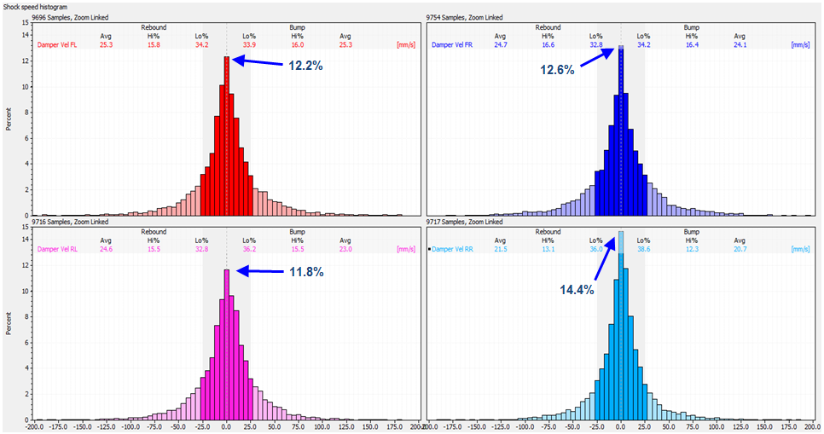
Figure 9 Example of shock speed histograms in Motec i2

In the example above the zero bin includes data where the shock speed was between -0.5 and +0.5mm/s, so it includes some bump and some rebound speeds. Some software packages create histograms without a zero bin, such as the example in Figure 10 taken from Magnetti Marelli's Wintax software. In this case the zero bin should be calculated by taking the sum of the bin content directly left and directly right of zero.
In the example below the height of the zero bin would be 30.16 + 18.02 = 48.18% and this bin would include shock speed values between -12.5 and +12.5mm/s. In this example it would also probably be better to choose a smaller bin width as the zero bin contains about half of all the measured samples.

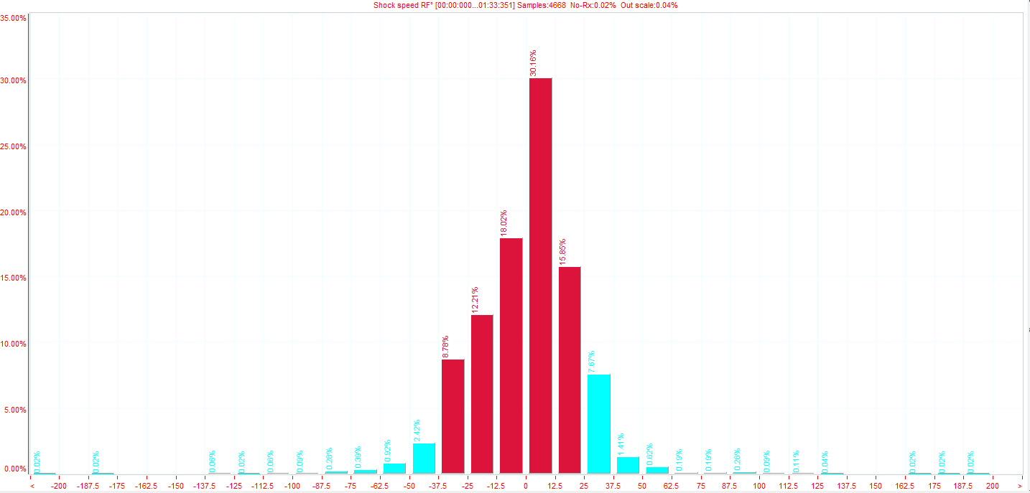
Figure 10 Example of shock speed histogram in Magnetti Marelli Wintax

  - Histogram asymmetry

The asymmetry of the shock speed histogram will tell us something about the way the respective suspension corners are damped. We previously established that we'd like our histograms as symmetric as possible. To evaluate symmetry we could compare each speed bin in bump to its rebound counterpart. An easier method is to determine the boundary between high speed and low speed damper movement and calculate the histogram surface for these 2 speed intervals for bump and rebound.
In the example below low speed is defined as damper movement slower than 25mm/s. Everything above is considered high speed. The Motec i2 software in which this histogram was created automatically calculates the percentages spent in high and low speed for bump and rebound.
The pink coloured bins represent the high speed interval, the left one for rebound and the right one for bump. The percentage spent in high speed rebound is 16.7% while in bump this percentage is 16.5%. High speed damper movement can be considered as symmetrical in bump and rebound. There is however a considerable difference in low speed damper movement with 35.0% in bump and 31.7% in rebound. Softening low speed bump or increasing low speed rebound will decrease the difference between the 2 percentages. Which of those 2 options is the best will depend on the direction you want to go with the setup or what type of handling problem you're trying to solve.

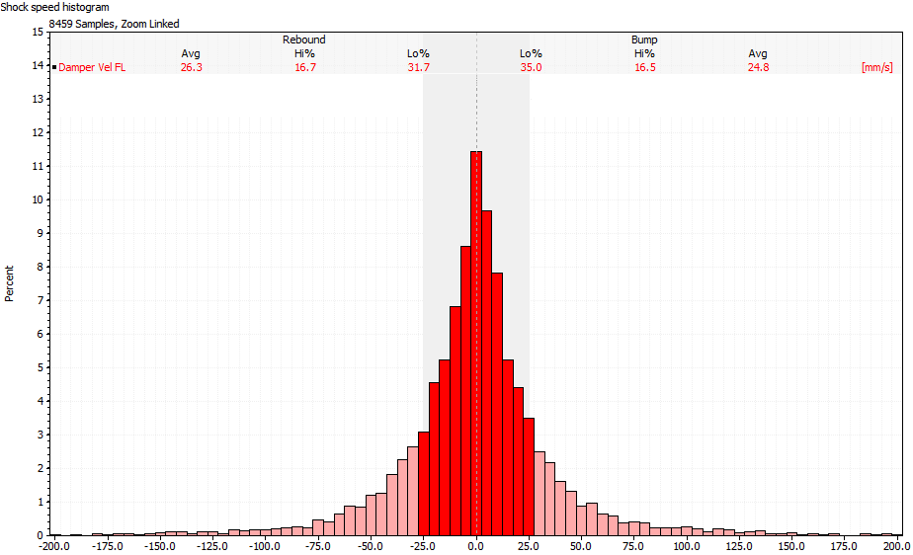
Figure 11 Motec i2 histogram illustrating asymmetry in low speed damping

In race cars producing high amounts of downforce the rebound damping is often used to influence the attitude of the car (ride height control). In these cases the shock speed histograms will probably not be symmetrical.

  - Statistics

To put some numbers on the shape of the shock speed histogram we can calculate a number of statistical values that make it easier to compare different histograms. Most of these calculations are not available within the data analysis software, so rely on the possibility to export the shock speed data into Microsoft Excel or Matlab.

    - Percentage of time spent in bump and rebound

When we count the amount of data samples with positive and negative speeds and divide these 2 totals by the total amount of sampled shock speeds we get the distribution of shock speed in bump and rebound. The side with the biggest percentage produces most of the damping forces. For symmetry reasons both percentages should be as close as possible to 50%.

    - Average shock speed

The average shock speed should always be very close to zero. If this is not the case there is probably something wrong with the shock velocity calculation.

    - Average shock speed in bump and rebound

Taking separate average speeds for bump and rebound gives us a measure of how much each movement is damped

    - Median

The median is the middle value of all measured points. In case of a Gaussian shock speed distribution the median would be zero. A negative median means that the distribution is biased to the rebound side, and vice versa.

    - Variance / Standard deviation

Variance σ and the standard deviation σ³ are a measure of the width of the histogram. The lower the standard deviation, the more time is spent at lower shock speeds. A higher standard deviation means that more time is spent at higher speeds.
The standard deviation doesn't tell us anything about the asymmetry of the histogram. There can well be more time spent in low speed rebound compared to low speed bump with an equal standard deviation when the situation would be in the other direction.

    - Skewness

Skewness is a measure for the asymmetry in the histogram. A negative skewness means that the histogram is biased towards the rebound side. The histogram is positively skewed if it is biased towards the bump side.

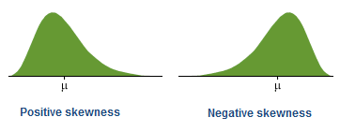
Figure 12 Skewness
    - Kurtosis

The kurtosis value tells us something about the 'peakedness' of the histogram. The 2 distributions in the illustration below have an equal standard deviation but the left one has a lower kurtosis than the right one. The higher the kurtosis value, the higher the peak of the histogram.

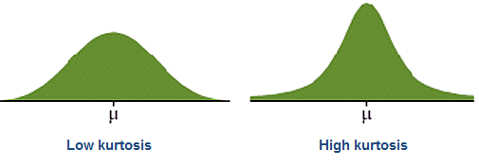
Figure 13 Kurtosis

- Practical examples

- How to use the shock speed histogram spreadsheet

